DISCLOSURE OF INVENTION

- Particulars of inventor(s)
S. No. | Name of the Inventor(s) | Organization / department and designation (if applicable) | Nationality | Email and Phone number
1 | Mr. Deepankar Sharma | Department of Computer Science and Engineering,  Graphic Era Hill University, Haldwani | India | deepankarsharma.20041299@gehu.ac.in
2 | Ms. Sujata Negi Thakur | Department of Computer Science and Engineering,  Graphic Era Hill University, Haldwani | India | sujatanegi@gehu.ac.in
3 | Mr. Manoj Kumar Singh | School of Computing,  Graphic Era Hill University,  Bhimtal | India | mthakur@gehu.ac.in

- Kindly attach more sheets if required
- Please feel free to attach additional drawings if needed to explain your response(s). In addition, please attach any supplemental materials that you think might help illustrate your invention.

- Particulars of invention

- Title of the invention
Self Customized AI Student-Counsellor System using Recommendation Systems and Reinforcement Learning.
- General purpose of the invention:
Having too many options also makes you misguided sometimes. The students these days face similar problem regarding their career paths and setting up their goals. The life of students is tough, there’s always some constant pressure from many dimensions like peer, family, teachers, etc. And the individuals start to loose clarity in their interests, arenas and eventually this leads to misguided goals.We can’t imagine the exposure of information a student gets these days, and having that much information works as a distraction most of the times.
- Flowchart, process, method, algorithm and diagram of the invention
Inputs:
- Interests
- Marks / Subject-wise
- Routine
- Schedule per subject
- Other Curricular Activities
- Bad Habits (if any)
- Possible distractions
- ….……………
Mechanism:
- Interests
- Marks / Subject-wise

- Routine
- Schedule per subject
- Other Curricular Activities

AI assistant + Recommender System

CLASSIFY ARENAS
CALCULATE PERFORMANCE SCORE

PREDICT FUTURE PERFORMANCE SCORE
VS ROUTINE

SET UP GOALS FOR STUDENTS
Performance Score increased

(positive reward)
Performance Score decreased

(negative reward)

- Abstract

The idea is to develop an AI Assistant cum Recommendation System Application that will be serving as a self customized AI-Counsellor. The model would be made with advanced NLP so that Natural Conversation Interface would feel like very friendly environment to the users.
The Application would work on very simple algorithms like Regression, Classification , PCA , Recommendation Systems and Reinforcement Learning built on top of it. The input to the application would be lot of input features like: Interests, Subject-wise scores, Routine, Schedule per subject, social media usage , extra curricular activities etc.

Now applying PCA over this data would help to classify “Arena/Domain” interests of the user as well as calculate a numeric performance score of the user. A simple regression model would help to predict the future performance score on basis of a routine. Further more the application will help students to come up with a better time schedule , let them identify their strong domains and recommend them which areas they need to work on. Also the application will set up frequent goals for the students to provide them better guidance.

Now the application will be smart enough to customize itself according to student’s progress as if achieving certain goals leads to increase in performance score of student , it’ll yield a positive reward for the AI-assistant, otherwise negative.

Signature of Applicant
Dt:

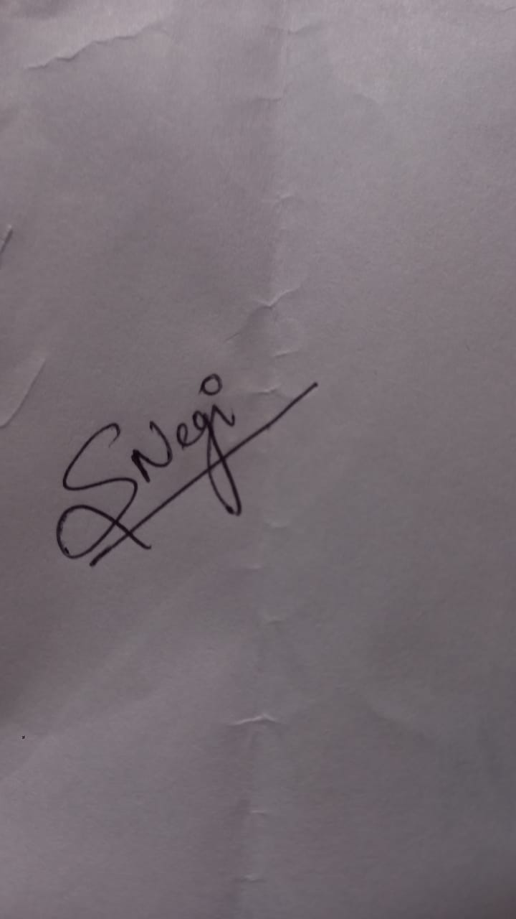
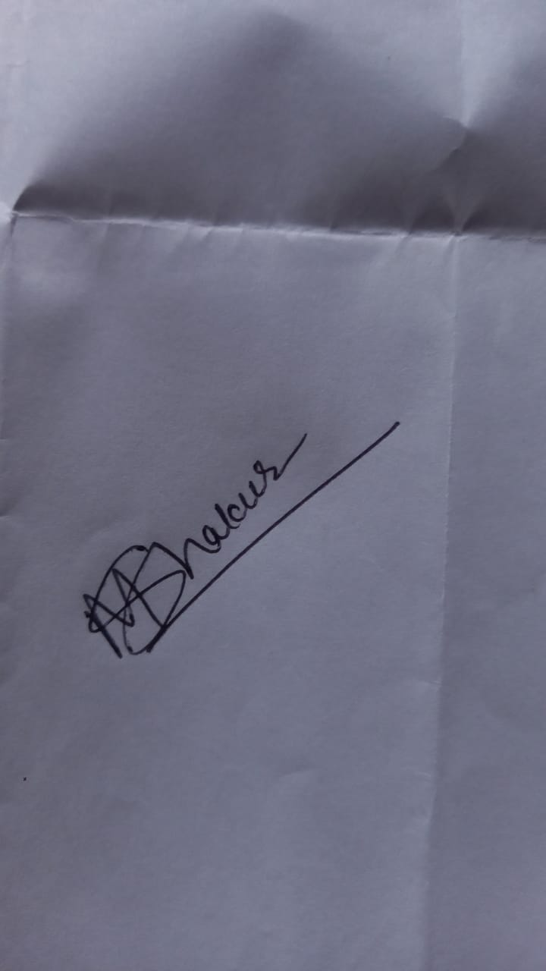

Remark of IP Cell

Signature IP Head

Remarks of Dean Office

Signature

